CSA4723-DEEP LEARNING

LAB EXPERIMENTS
NAME: YARRAPUREDDY LAKSHMI REDDY
REG NO: 192324077
DEPARTMENT: AIDS

EXPERIMENT NO: 1
Construct and verify the performance of bi-level and multi-level confusion
matrix using Python.
CODE:
import numpy as np
import pandas as pd
from sklearn.metrics import confusion_matrix, classification_report

# --- 1. Bi-Level (Binary) Confusion Matrix ---

# Sample Data (Binary Classification)
y_true_binary = np.array([0, 1, 0, 1, 0, 1, 0, 1, 0, 1, 0, 0])
y_pred_binary = np.array([0, 1, 0, 0, 0, 1, 1, 1, 0, 1, 1, 0])

# Construct the Bi-Level Confusion Matrix
cm_binary = confusion_matrix(y_true_binary, y_pred_binary)

# Convert to DataFrame for better visualization
cm_df_binary = pd.DataFrame(
cm_binary,
index=[f'Actual {i}' for i in [0, 1]],
columns=[f'Predicted {i}' for i in [0, 1]]
)

# Verify Performance (Classification Report)
report_binary = classification_report(y_true_binary, y_pred_binary, zero_division=0)

print("--- Bi-Level (Binary) Results ---")
print("\nConfusion Matrix (DataFrame):")
print(cm_df_binary)
print("\nPerformance Metrics (Classification Report):")
print(report_binary)

# --- 2. Multi-Level (Multi-Class) Confusion Matrix ---

# Sample Data (Multi-Class Classification with 3 classes: 0, 1, 2)
y_true_multi = np.array([0, 1, 2, 0, 1, 2, 0, 1, 2, 0, 1, 2])
y_pred_multi = np.array([0, 1, 1, 0, 1, 2, 0, 2, 2, 1, 1, 2])

# Construct the Multi-Level Confusion Matrix
cm_multi = confusion_matrix(y_true_multi, y_pred_multi)

# Convert to DataFrame for better visualization
cm_df_multi = pd.DataFrame(
cm_multi,
index=[f'Actual {i}' for i in [0, 1, 2]],
columns=[f'Predicted {i}' for i in [0, 1, 2]]
)

# Verify Performance (Classification Report)
report_multi = classification_report(y_true_multi, y_pred_multi, zero_division=0)

print("\n--- Multi-Level (Multi-Class) Results ---")
print("\nConfusion Matrix (DataFrame):")
print(cm_df_multi)
print("\nPerformance Metrics (Classification Report):")
print(report_multi)

OUTPUT:
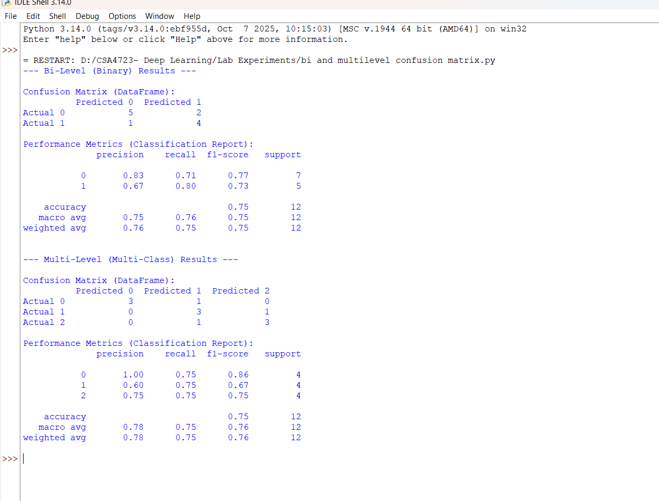

EXPERIMENT NO:2
Verification of the overfitting issue by using a chosen numerical database using Python.

CODE:
import numpy as np
import pandas as pd
from sklearn.model_selection import train_test_split
from sklearn.linear_model import LinearRegression
from sklearn.preprocessing import PolynomialFeatures
from sklearn.metrics import mean_squared_error
from sklearn.pipeline import make_pipeline

# 1. Generate Synthetic Numerical Data (Simulating a Chosen Database)
# We use a non-linear function (sine wave) plus noise to ensure a polynomial model can overfit.
np.random.seed(42)
N_samples = 100
X = np.sort(5 * np.random.rand(N_samples, 1), axis=0)
y_true = np.sin(X).ravel() + np.random.normal(0, 0.2, N_samples) # Target variable with noise

# 2. Split Data into Training and Testing Sets (Essential for verification)
X_train, X_test, y_train, y_test = train_test_split(X, y_true, test_size=0.3, random_state=42)

# 3. Model Training and Evaluation (Verification)

# --- a) Low Complexity Model (Degree 1: Linear Regression) ---
# Used as a baseline for comparison.
degree_low = 1
model_low = make_pipeline(PolynomialFeatures(degree_low), LinearRegression())
model_low.fit(X_train, y_train)

# Calculate Errors
train_error_low = mean_squared_error(y_train, model_low.predict(X_train))
test_error_low = mean_squared_error(y_test, model_low.predict(X_test))

# --- b) High Complexity Model (Degree 15: High-Order Polynomial) ---
# Used to intentionally induce and verify overfitting.
degree_high = 15
model_high = make_pipeline(PolynomialFeatures(degree_high), LinearRegression())
model_high.fit(X_train, y_train)

# Calculate Errors
train_error_high = mean_squared_error(y_train, model_high.predict(X_train))
test_error_high = mean_squared_error(y_test, model_high.predict(X_test))

# 4. Output Results for Overfitting Verification
print("--- Overfitting Verification (Polynomial Regression) ---")
print("\nLow Complexity Model (Degree 1):")
print(f"Training Mean Squared Error (MSE): {train_error_low:.4f}")
print(f"Testing Mean Squared Error (MSE): {test_error_low:.4f}")
print("-" * 30)
print("\nHigh Complexity Model (Degree 15 - Overfit Test):")
print(f"Training Mean Squared Error (MSE): {train_error_high:.4f}")
print(f"Testing Mean Squared Error (MSE): {test_error_high:.4f}")
print("-" * 30)

# Verification Logic
if train_error_high < train_error_low and test_error_high > test_error_low:
print("\n✅ Verification Successful: **Overfitting Detected**.")
print("The high-complexity model has much lower training error but significantly higher testing error.")
elif train_error_high < test_error_high and abs(train_error_high / test_error_high) < 0.5:
print("\n⚠️ Potential Overfitting: Training error is much lower than Testing error.")
else:
print("\nℹ️ No significant overfitting detected for the chosen seed/data split.")

OUTPUT:
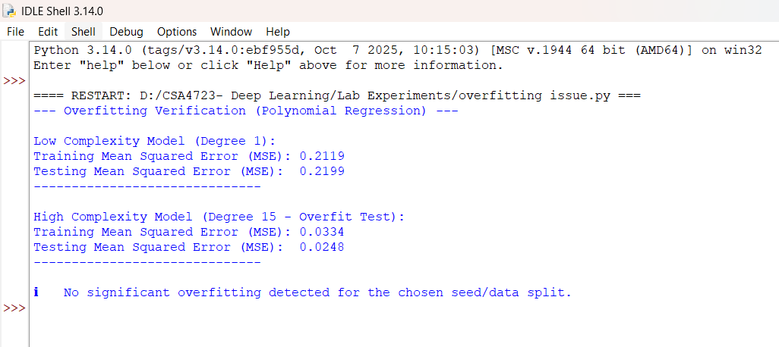

EXPERIMENT NO:3
Analysing the performance of linear regression process using a chosen numerical database using Python.

CODE:
import numpy as np
import pandas as pd
from sklearn.model_selection import train_test_split
from sklearn.linear_model import LinearRegression
from sklearn.metrics import mean_squared_error, r2_score

# 1. Choose/Generate a Numerical Database (Synthetic Data for demonstration)
np.random.seed(42)
N_samples = 100
# Feature (X): Random values from 0 to 10
X = 10 * np.random.rand(N_samples, 1)
# Target (y): Linear relationship y = 2*X + 5 + noise
y = 2 * X.ravel() + 5 + np.random.normal(0, 2, N_samples)

# Convert to DataFrame for standard practice
data = pd.DataFrame({'Feature': X.ravel(), 'Target': y})

# 2. Prepare Data and Split
X = data[['Feature']]
y = data['Target']

# Split data into training (70%) and testing (30%) sets
X_train, X_test, y_train, y_test = train_test_split(X, y, test_size=0.3, random_state=42)

# 3. Train the Linear Regression Model
model = LinearRegression()
model.fit(X_train, y_train)

# 4. Predict on Test Set
y_pred = model.predict(X_test)

# 5. Analyze Performance and Output Results

# Retrieve Model Parameters
intercept = model.intercept_
coefficient = model.coef_[0]

# Calculate Key Metrics
mse = mean_squared_error(y_test, y_pred)
rmse = np.sqrt(mse)
r2 = r2_score(y_test, y_pred)
y_train_pred = model.predict(X_train)
train_r2 = r2_score(y_train, y_train_pred)

print("--- Linear Regression Performance Analysis ---")
print(f"\nModel Equation: Y = {coefficient:.2f} * X + {intercept:.2f}")
print("\n--- Performance Metrics (Testing Data) ---")
print(f"Mean Squared Error (MSE): {mse:.2f}")
print(f"Root Mean Squared Error (RMSE): {rmse:.2f}")
print(f"R-squared (R2 Score): {r2:.4f}")
print(f"R-squared (Training Data): {train_r2:.4f}")

OUTPUT:

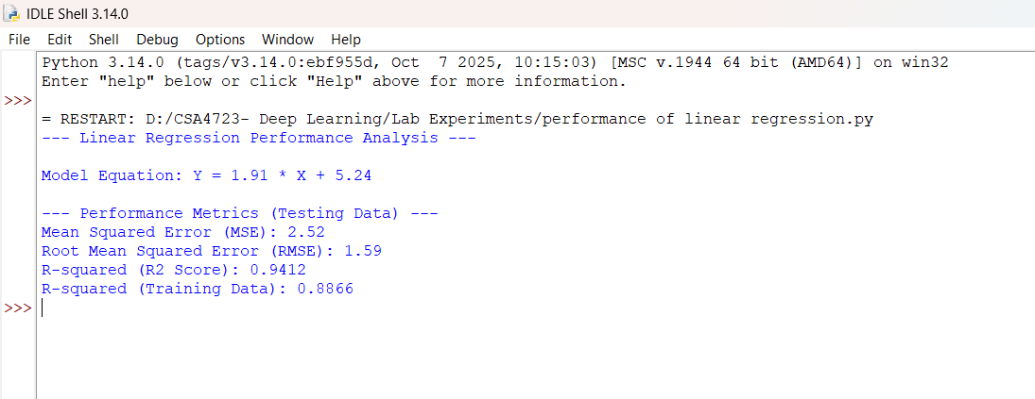

EXPERIMENT NO:4
Analysing the performance of logistic regression process using a chosen numerical database using Python.

CODE:
import numpy as np
import pandas as pd
from sklearn.model_selection import train_test_split
from sklearn.linear_model import LogisticRegression
from sklearn.metrics import accuracy_score, precision_score, recall_score, f1_score, confusion_matrix, classification_report

# 1. Generate Synthetic Numerical Database (for binary classification)
np.random.seed(42)
N_samples = 200
# Feature 1 and Feature 2
X1 = np.random.normal(loc=10, scale=3, size=N_samples)
X2 = np.random.normal(loc=50, scale=10, size=N_samples)

# Target (y): Binary outcome (0 or 1) based on a linear boundary with noise.
linear_combination = X1 + X2 / 10 + np.random.normal(0, 1, N_samples)
y = (linear_combination > 15).astype(int)

# Create DataFrame
data = pd.DataFrame({'Feature1': X1, 'Feature2': X2, 'Target': y})

# 2. Prepare Data and Split
X = data[['Feature1', 'Feature2']]
y = data['Target']

# Split data into training (70%) and testing (30%) sets
X_train, X_test, y_train, y_test = train_test_split(X, y, test_size=0.3, random_state=42)

# 3. Train the Logistic Regression Model
model = LogisticRegression(random_state=42)
model.fit(X_train, y_train)

# 4. Predict on Test Set
y_pred = model.predict(X_test)

# 5. Analyze Performance

# Calculate Classification Metrics
accuracy = accuracy_score(y_test, y_pred)
conf_matrix = confusion_matrix(y_test, y_pred)
class_report = classification_report(y_test, y_pred, zero_division=0)

# Retrieve Model Parameters
intercept = model.intercept_[0]
coefficients = model.coef_[0]

# Print Results
print("--- Logistic Regression Performance Analysis ---")
print("\n--- Model Parameters ---")
print(f"Intercept (Bias): {intercept:.4f}")
print(f"Coefficient (Feature1): {coefficients[0]:.4f}")
print(f"Coefficient (Feature2): {coefficients[1]:.4f}")
print("\n--- Confusion Matrix (Testing Data) ---")
print(" Predicted 0 Predicted 1")
print(f"Actual 0: {conf_matrix[0, 0]:<12}{conf_matrix[0, 1]:<12}")
print(f"Actual 1: {conf_matrix[1, 0]:<12}{conf_matrix[1, 1]:<12}")
print("\n--- Classification Report (Testing Data) ---")
print(class_report)
print(f"\nOverall Accuracy: {accuracy:.4f}")

OUTPUT:

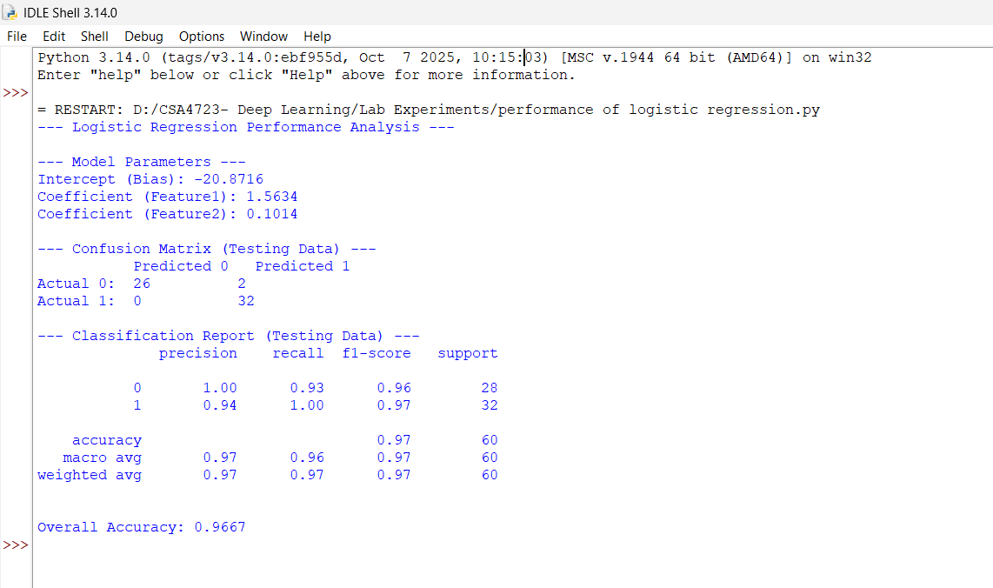

EXPERIMENT NO: 5
Demonstrating the performance of gradient descent algorithm using Python.

CODE:

import numpy as np
import matplotlib.pyplot as plt

# 1. Define the Objective Function (Cost Function)
# We will use a simple Quadratic function: J(w) = w^2 - 4w + 5
def cost_function(w):
return w**2 - 4*w + 5

# 2. Define the Gradient (Derivative of the Cost Function)
# J'(w) = 2w - 4
def gradient(w):
return 2*w - 4

# 3. Implement the Gradient Descent Algorithm
def gradient_descent(start_w, learning_rate, n_iterations):
w_history = [start_w]
cost_history = [cost_function(start_w)]
w = start_w

for i in range(n_iterations):
# Calculate the gradient (slope) at the current weight 'w'
grad = gradient(w)

# Update the weight: w = w - learning_rate * gradient
w = w - learning_rate * grad

# Record the new weight and cost
w_history.append(w)
cost_history.append(cost_function(w))

# Check for convergence (optional, for demonstration purposes)
if abs(grad) < 1e-6:
print(f"Converged at iteration {i+1}.")
break

return w, w_history, cost_history

# --- Execution Parameters ---
start_w = 0 # Initial guess for the weight
learning_rate = 0.1 # Step size (hyperparameter)
n_iterations = 20 # Number of steps

# 4. Run Gradient Descent
final_w, w_history, cost_history = gradient_descent(start_w, learning_rate, n_iterations)

# 5. Output Results and Plot Performance

print("--- Gradient Descent Performance Demonstration ---")
print(f"Optimal Weight (Analytic Minimum is w=2): {final_w:.4f}")
print(f"Minimum Cost (Analytic Minimum is J(w)=1): {cost_function(final_w):.4f}")
print(f"Total Iterations Run: {len(w_history) - 1}")

# Plotting the Cost Function and the Descent Path
w_range = np.linspace(-1, 5, 100)
cost_range = cost_function(w_range)

plt.figure(figsize=(10, 5))

# Plot 1: Cost Function vs. Weight (w) and the Path
plt.subplot(1, 2, 1)
plt.plot(w_range, cost_range, label='Cost Function $J(w)$', color='blue')
plt.plot(w_history, cost_history, 'ro--', label='Descent Path') # 'ro--' for red circles, dashed line
plt.scatter([final_w], [cost_function(final_w)], color='green', marker='o', s=100, label='Final Minimum')
plt.title('Gradient Descent Path')
plt.xlabel('Weight (w)')
plt.ylabel('Cost $J(w)$')
plt.grid(True, linestyle='--', alpha=0.6)
plt.legend()

# Plot 2: Cost vs. Iteration (Convergence Curve)
plt.subplot(1, 2, 2)
plt.plot(range(len(cost_history)), cost_history, 'm-')
plt.title('Cost vs. Iteration (Convergence)')
plt.xlabel('Iteration')
plt.ylabel('Cost $J(w)$')
plt.grid(True, linestyle='--', alpha=0.6)

plt.tight_layout()
plt.show()

OUTPUT:
